**FILE I/O**

A file is pattern of data which stored in the disk.

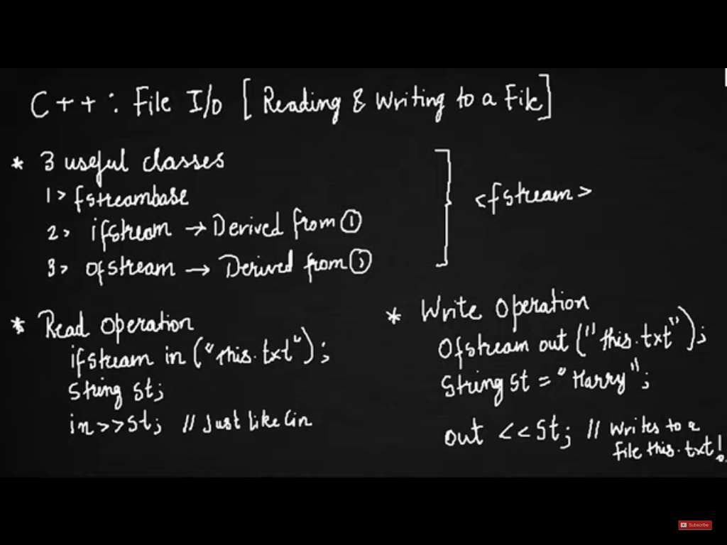

open() --> a function in class ifstream and ofstream. It is used to open a file

eof()